Machine Description | The machine contains a Sensitive Information Disclosure vulnerability that exposed valid SSH credentials, leading to unauthorized system access.
Target Machine IP | 192.168.0.105
Vulnerability Name | Remote code Execution, Sensitive Information disclosure, & also vulnerable version of Tiki Wiki CMS Groupware affected by a SQL Injection vulnerability
Service & Version | 80 TCP/HTTP(Apache)  22 TCP/SSH
CVSS Score and Severity | 9.8 Critical
Attack Vector | CVSS:3.0/AV:N/AC:L/PR:N/UI:N/S:U/C:H/I:H/A:H
Proof of Concept | Step 1: The target machine’s IP address was identified using the Netdiscover tool during network scanning.  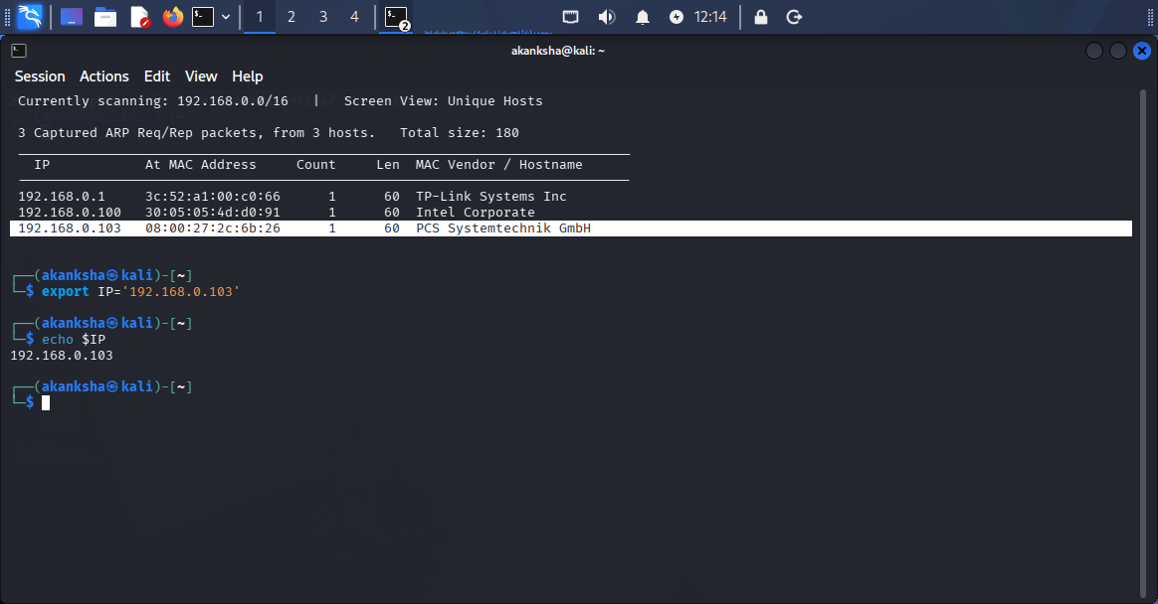  Step 2: The target machine was scanned using the Nmap tool to identify open ports, services, and potential vulnerabilities  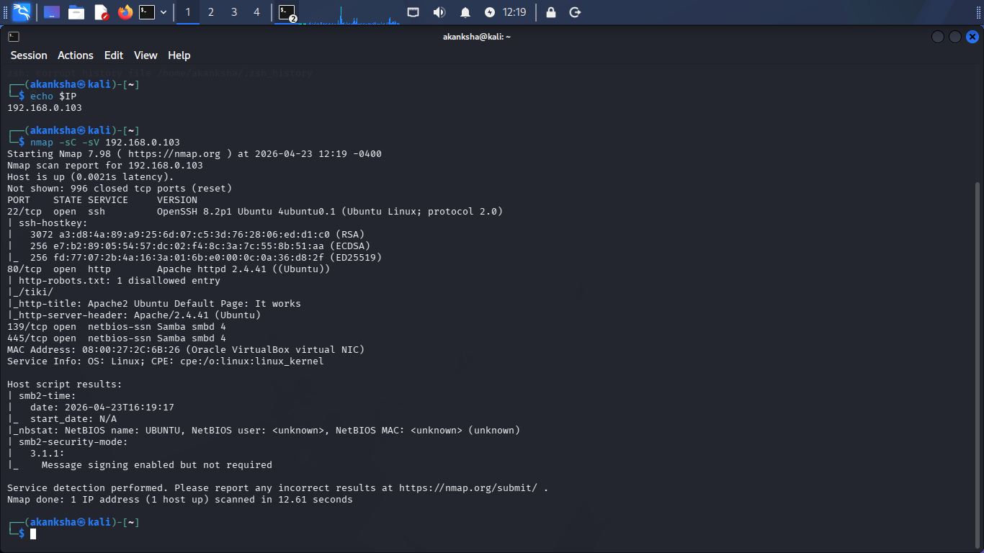  Step 3: Port 80 was enumerated to analyze the web service and identify accessible resources, directories, and potential vulnerabilities.  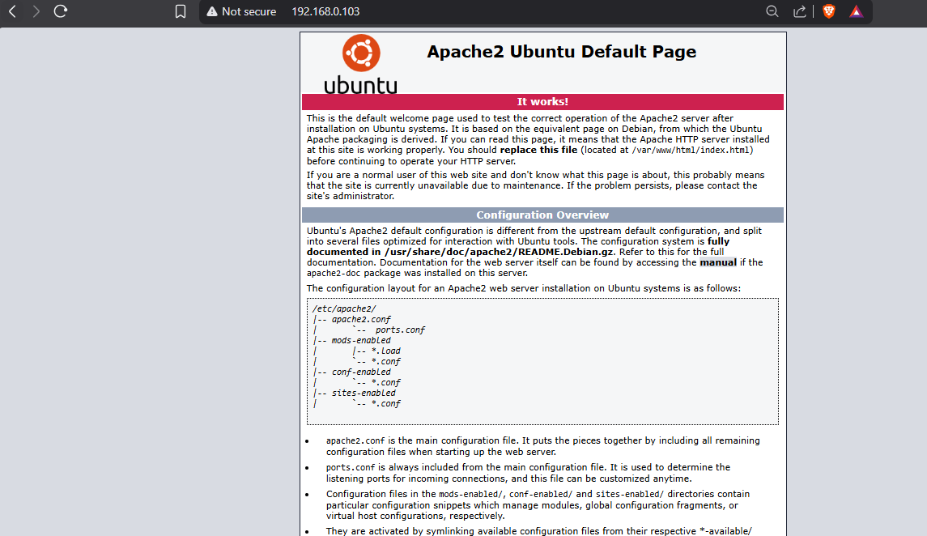  - Web directory fuzzing was performed using Wfuzz and SecLists wordlists to identify hidden directories, files, and potential attack surfaces exposed by the target web application.  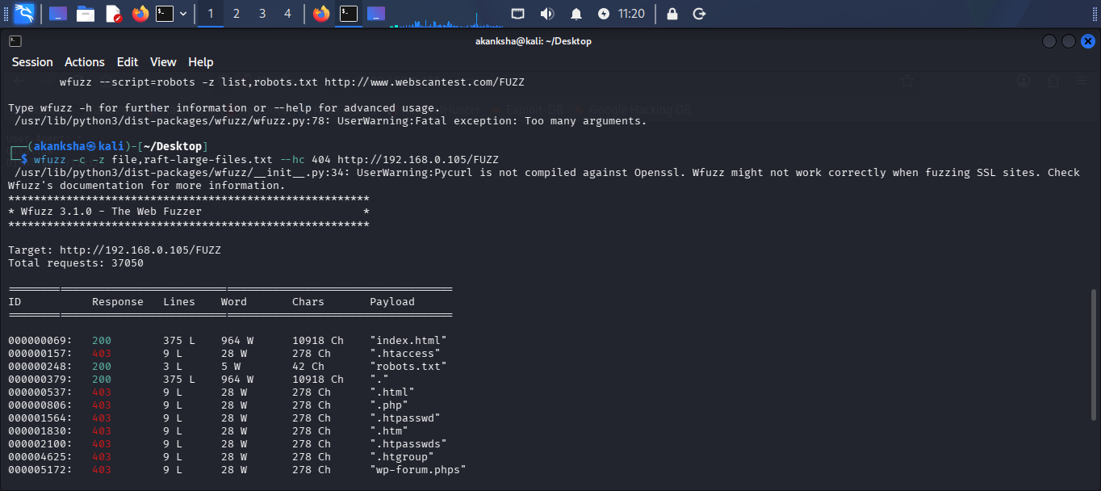  - During fuzzing, valid HTTP 200 responses were identified for index.html and robots.txt, indicating accessible web resources on the target application.  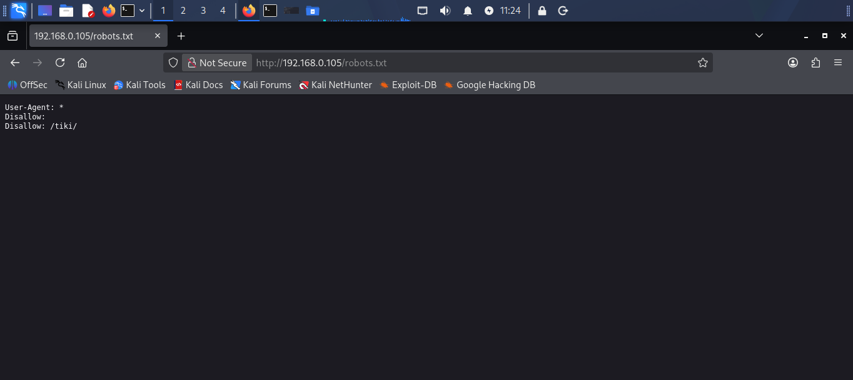  - It says Disallow /tiki lets visit it. Here we got default webpage for CMS and CMS login  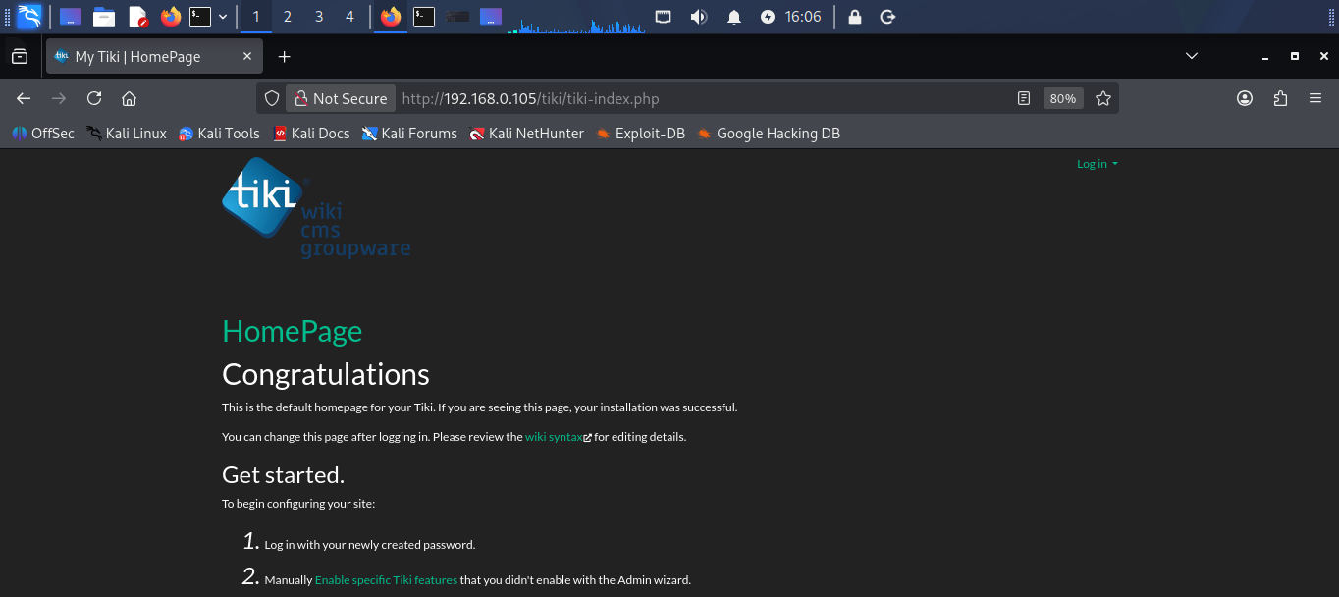  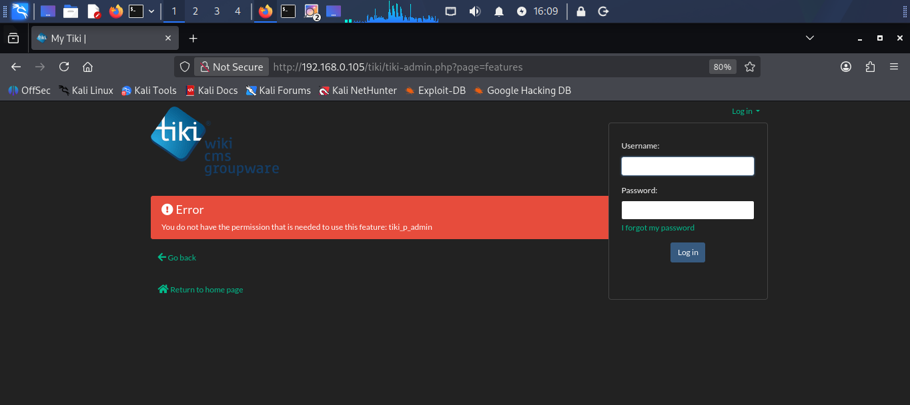  - We tried multiple things here we didn’t get much lets go for the SMB enumeration and find what we could get  STEP 4: Look for if Null session possible and any open shares using Enum4linux  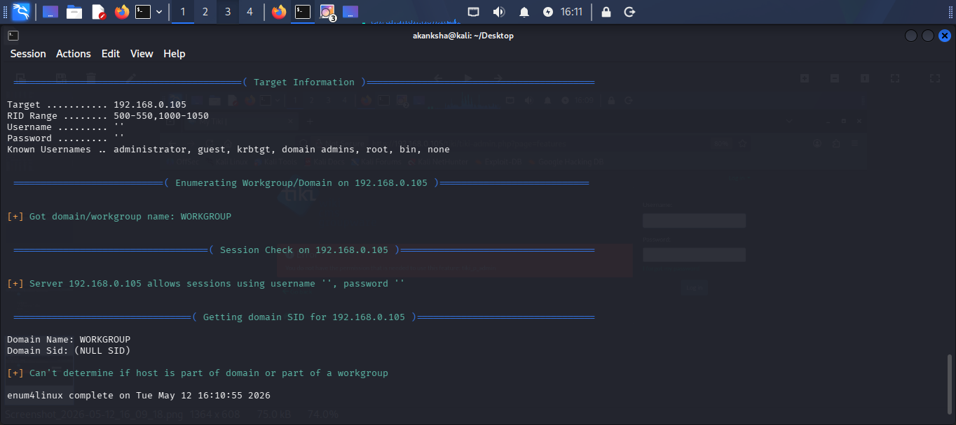  - It does allows null sessions lets list available shares ( -N for no password prompt and -NL for list all available shares  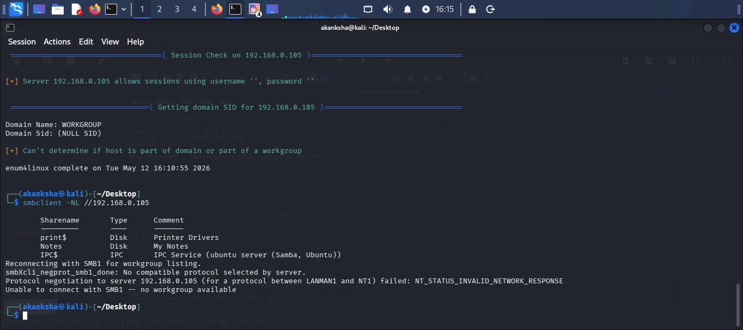  - Lets try to get null session login see what’s in Notes  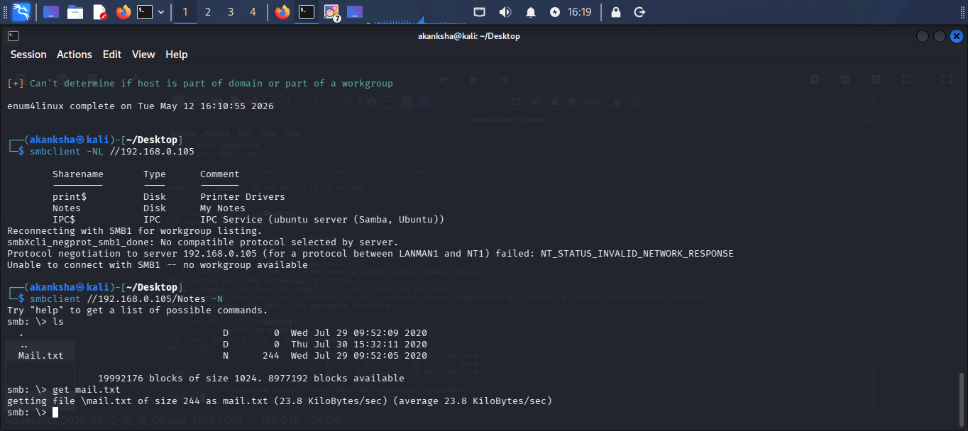  - We Got file Mail.txt  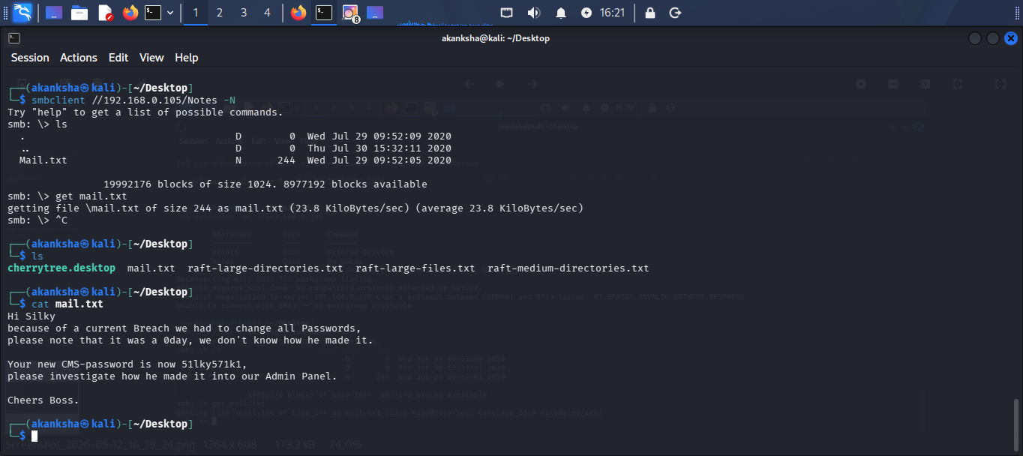  - We get password silky: 51lky571k1  - Let’s try to authenticate on CMS  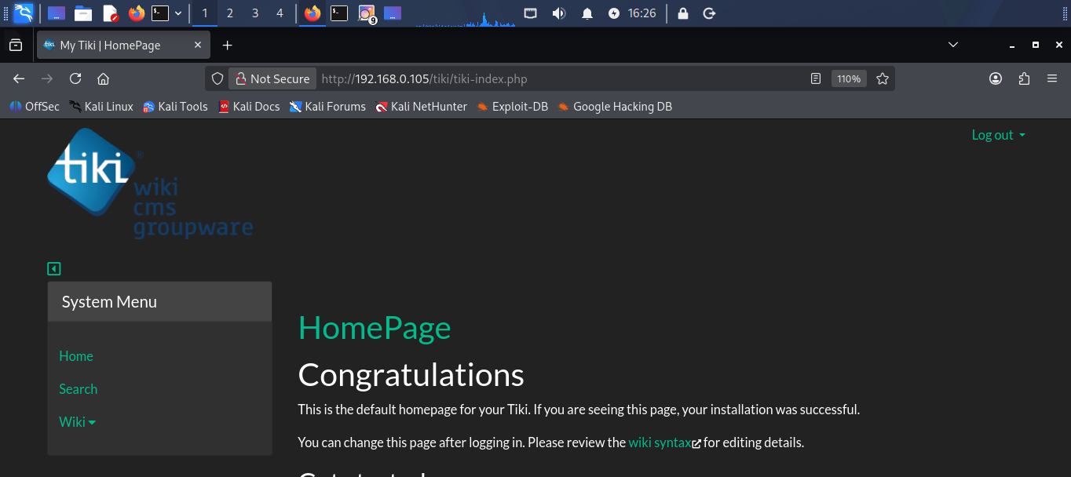  - We got Login Here after fuzzing we found here again /tiki/robots.txt and from here we visited /tiki/changelog.txt that most of the cms might have and where we got our version for CMS so it Version 21.1 lets try to find Exploit Code to abuse version  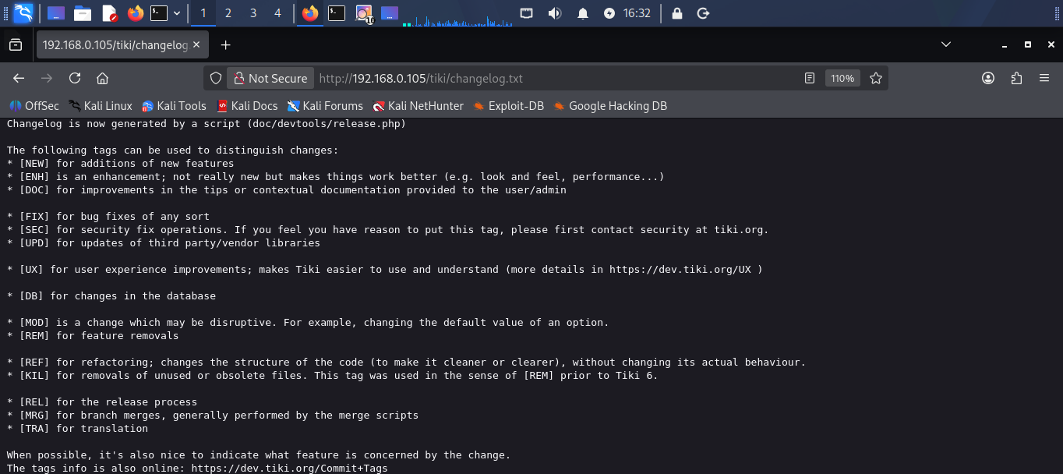  - Searchsploit tiki 21 so we do have one  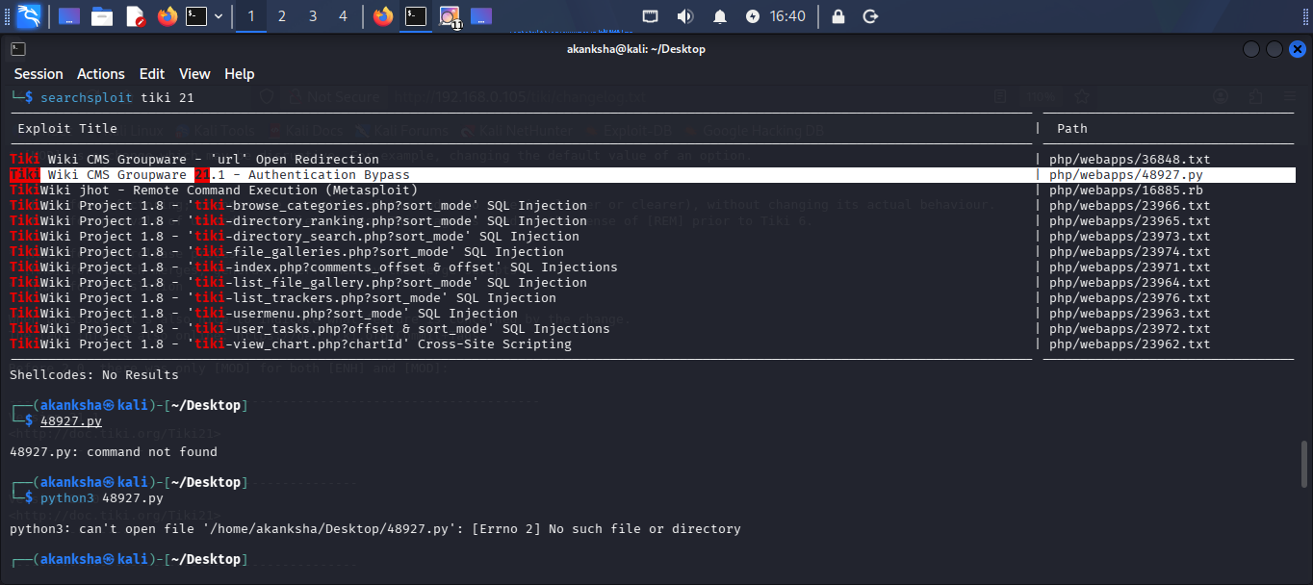  - Its simple to user not need to modify exploit  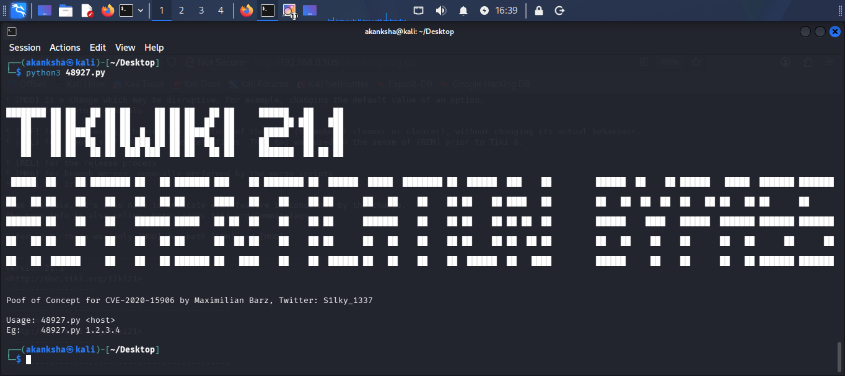  STEP 5 – Running Exploit Code  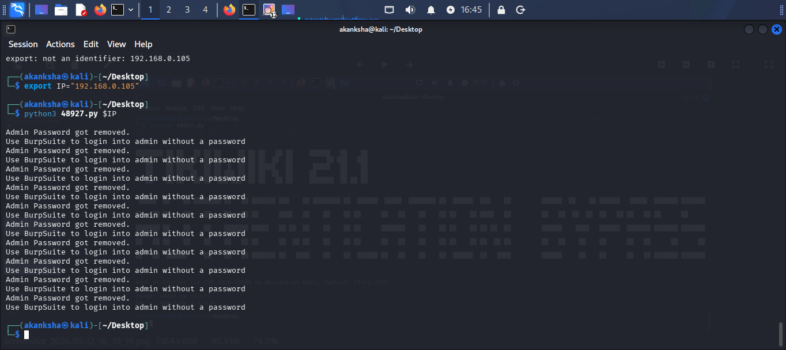  - We got authentication Bypass says Admin Password got Removed this it means we can user Burpsuite and pass empty password for user and we can get admin login  STEP 6: Passing No password for admin user using burpsuite and trying to bypass authentication  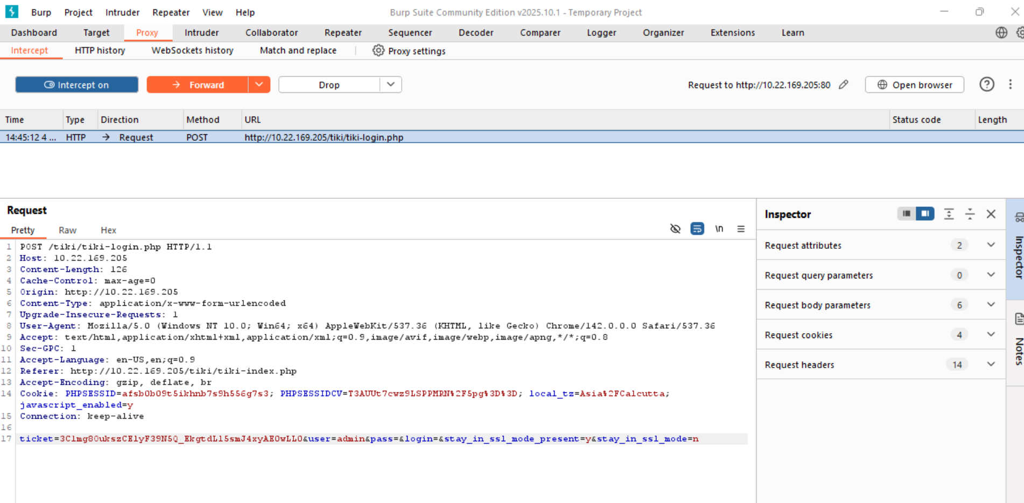  - We Login as Admin  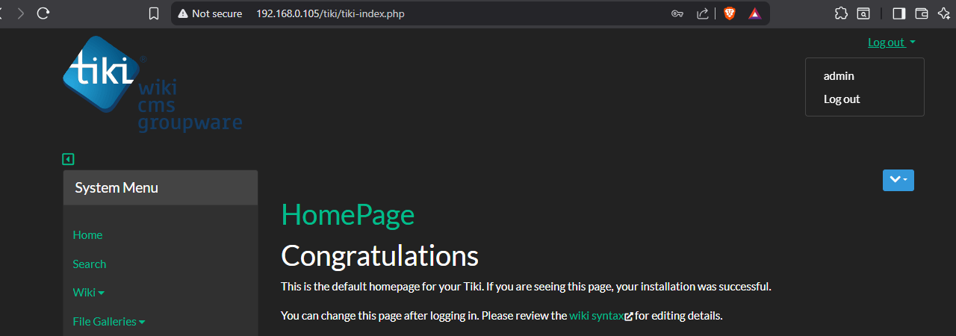  - Sensitive credentials for the user silky were discovered within the CMS during post-enumeration activities, leading to successful SSH authentication. (silky: Agy8Y7SPJNXQzqA)  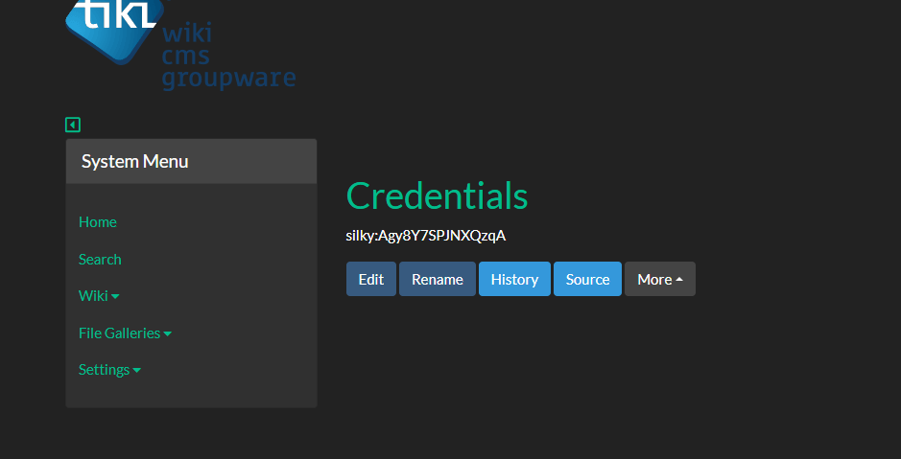  STEP: login using SSH  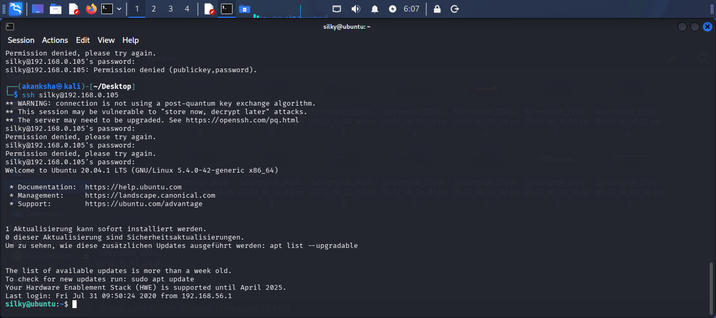  - List permission sudo -l we do have root perms for silky user  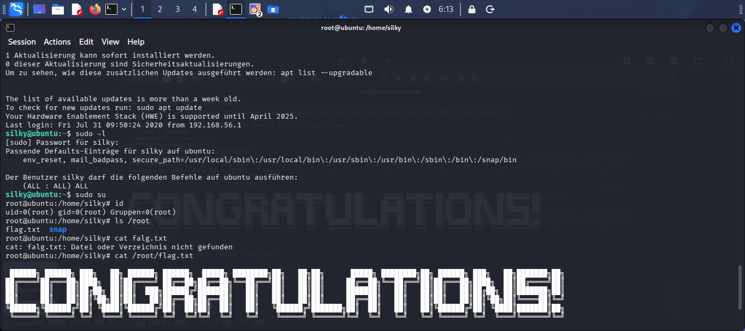  We have solved the machine successfully
Impact | - Allows unauthorized SSH login  - Leads to remote shell access  - Can result in privilege escalation  - May expose sensitive system files  - Can lead to complete server compromise
Remediations | - Remove exposed credentials from publicly accessible locations  - Implement strong authentication and access control mechanisms  - Enforce strong and unique passwords for all user accounts  - Restrict SSH access to authorized users only  - Regularly update and patch the Tiki Wiki CMS application
Reference | https://www.vulnhub.com/

